**MAJOR PROJECT**

On

**DEEP LEARNING FRAMEWORKS FOR SUPER IMAGE RESOLUTION**

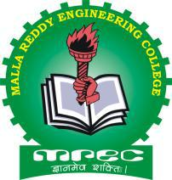

*submitted in the partial fulfillment of the requirements for the*

*award of degree of*

**BACHELOR OF TECHNOLOGY**

in

**COMPUTER SCIENCE AND ENGINEERING**

by

**Mr. Mithilesh 16J41A05C8**

**Mr. Ch. Nag Kamal 16J41A05D3**

**Mr. G. Uday Kumar 16J41A05E5**

**Mr. Satya Kumar 16J41A05H9**

**Mr. S. Rakesh 17J45A0505**

under the guidance of

**Dr. S. Dhanalakshmi**

Professor

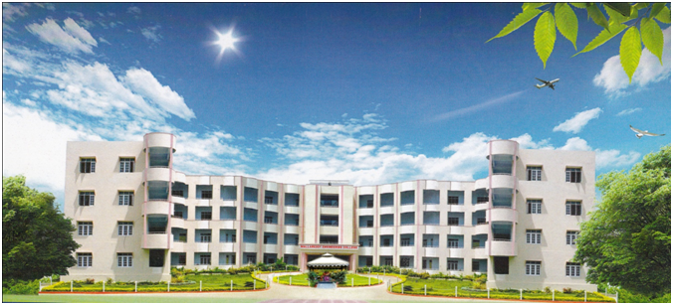

**DEPARTMENT OF COMPUTER SCIENCE AND ENGINEERING**

**MALLA REDDY ENGINEERING COLLEGE (AUTONOMOUS)**

(A UGC Autonomous Institution, Approved by AICTE and affiliated to JNTUH Hyderabad,

Accredited by NAAC (II Cycle) with ‘A’ Grade and NBA)

Maisammaguda, Dhulapally (Post. Via. Kompally), Secunderabad – 500100,Telangana State.

**2016- 2020**

|  |  |
| --- | --- |
|  | **MALLA REDDY ENGINEERING COLLEGE**  **(AUTONOMOUS - MAIN CAMPUS)**  (A UGC Autonomous Institution, Approved by AICTE and affiliated to JNTUH Hyderabad,  Accredited by NAAC (II Cycle) with ‘A’ Grade and NBA)  Maisammaguda, Dhulapally (Post. Via. Kompally), Secunderabad – 500100, Telangana State. |

**DEPARTMENT OF COMPUTER SCIENCE AND ENGINEERING**

**CERTIFICATE**

This is to certify that the major project titled **“Deep learning frameworks for super image resolution”** is a bonafide work done by **Mithilesh**(**16J41A05C8),Nag Kamal(16J41A05D3), Uday kumar(16J41A05E5), Satya Kumar(16J41A05H9)and Rakesh(17J45A0505)** in partial fulfillment for the award of degree of Bachelor of Technology in Computer Science and Engineering, Jawaharlal Nehru Technological University Hyderabad**,** Hyderabad and that this work has not been submitted for the award of any other Degree/Diploma of any Institution/University.

Project Guide Head of the Department

**Dr. S Dhanalakshmi Dr. O. Obulesu**

Professor Professor

**External Examiner**

**DECLARATION**

We hereby declare that the majorproject titled **“Deep learning frameworks for super image resolution”** is original and bonafide work of our own, submitted to the Department of Computer Science and Engineering, Malla Reddy Engineering College (Autonomous), Hyderabad in the partial fulfillment of the requirements for the award of degree of Bachelor of Technology in Computer Science and Engineering, under the guidance of **Dr. S. Dhanalakshmi,** Professor and has not been copied from any earlier reports/works.

|  |  |  |
| --- | --- | --- |
| Roll No | Name | Signature |
| 16J41A05C8 | Mr. Mithilesh |  |
| 16J41A05D3 | Mr. Nag Kamal |  |
| 16J41A05E5 | Mr. Uday Kumar |  |
| 16J41A05H9 | Mr. Satya Kumar |  |
| 17J45A0505 | Mr. Rakesh |  |